Moodle Offline Project

Moodle Offline Project 1
1.0 Introduction 1
2.0 Development Tasks 7
3.0 Solution Architecture / Technical Feasibility 9
4.0 Moodle Offline Developer Framework 15
Current Achievements 20
Planned Development 20
General 21
Data Identification 25
Data Filter 27
Data Transfer 28
Data Merge 29
Data Update 30
User Interface 32
5.0 UMPC Operating Platform and Software Stack 36
6.0 Moodle Offline Installation Wizard 37
7.0 Moodle Offline Support Issues 38
Appendix A: User Interface 39
Snapshot 39
Glossary 40

Project Team:
Dat Thanh Le, Colin Chambers, Frederic Lepied / May 2007

1.0 Introduction
The aims of this project are:
- to make available Moodle as a fully functional application on a desktop personal computer;
- to allow Moodle, where appropriate, to operate regardless of whether it is connected or disconnected from the Internet;
- to support data synchronisation from Moodle on a server to Moodle on a desktop personal computer, and vice versa; and to offer a user administration interface to manage this synchronisation process;

1.1 Moodle Offline
Moodle Offline is the name given to an instance of Moodle operating on a desktop personal computer.
Moodle Hub is the name given to an instance of Moodle operating on a hosted server environment.
Personal Learning Environment is the name given to a learning environment under the control of an individual user.
Virtual Learning Environment is the name given to a learning environment controlled by a community or often a teaching institution.

Moodle Offline Code
Moodle Offline will be based on the code base found in moodle.org with the developers on this project anticipating no major changes to Moodle core (i.e. no introduction of backward compatibility issues).

Moodle Offline Operating Stack
Moodle Offline will operate on a hardware stack as prescribed by Moodle which can be one of any of the following combinations:
- Windows, Apache/Web, MySQL/DB, PHP (WAMP)
- Linux, Apache/Web, MySQL/DB, PHP (LAMP)
These elements are commonly referred to as, respectively, the operating system, the web server, the database and the application programming language.
The project will investigate a stack which consumes the least hardware resources from a desktop personal computer whilst offering acceptable performance levels. The components subject to potential change will be the web server and the database.

Moodle Offline Supported Platforms (OS and Hardware)
In theory, the operating stack can operate on a Microsoft Windows platform or a Linux platform (which includes Mac OS X). This project will concentrate development and testing on a Microsoft Windows platform only.
This project will not make design choices that are detrimental to supporting Moodle Offline on the Linux platform. Note: actual testing of platforms other than Microsoft Windows will be left to future development phases.

From one perspective, the technical specification for the desktop personal computer that can host and operate Moodle Offline is that specified by the Open University as described here:
http://www3.open.ac.uk/personal-computing/tech.shtm
http://www3.open.ac.uk/personal-computing/courses/Basic2008.shtm
http://www3.open.ac.uk/personal-computing/courses/Standard2008.shtm

From another perspective, the ideal target platform is that of the Ultra Mobile Personal Computer (UMPC) as described here:
http://www.intel.com/design/mobile/platform/umpc.htm
http://origamiproject.com/faqs/opfaq.aspx
http://origamiproject.com/default.aspx
http://umpc.com/default.aspx
http://www.microsoft.com/windows/products/winfamily/umpc/default.mspx
The UMPC is a platform that demonstrates a balance combination of processing power capable of running Moodle yet portably mobile and in a small form factor to support a user potentially operating Moodle on the move (from home to work or travel, in the car, on a train or plane).

Henceforth, this project will refer to the operating platform that can operate Moodle Offline as the UMPC platform.

1.2 Moodle Offline Disconnected
Moodle, without modification, can operate with or without an internet connection.
In principle:
- without an internet connection, Moodle operates in a close community and is accessible only by those who have direct physical access to the machine that is hosting Moodle;
- with an internet connection, Moodle can be accessed by those who can communicate and connect with the machine that is hosting Moodle;
- with an internet connection, Moodle can communicate and access internet services;

Moodle Offline is focused on principle’s 1 and 3; with no intention of making Moodle Offline a server application or an internet accessible service as implied in principle 2.

Firstly, it is about providing an isolated personal Moodle instance that can be accessed by, and only by, the owner of the desktop personal computer that hosts Moodle Offline.
This point is made to emphasise that this project will respect the user’s personal computer security by not requiring any incoming firewall ports to be opened or expect the personal computer to become accessible on the internet. Moodle Offline is a personal desktop computer application that pulls information and services from the Internet as if it was a web browser grabbing web pages from a web server.

Secondly, it is about enabling Moodle Offline to communicate and synchronise with a Moodle Hub to acquire information and services provided by another institution that the user has some known affiliation with.
This point is clarified further in the next section.

Moodle Offline in the disconnected mode is also referred to as offline Moodle.

1.3 Moodle Offline and Data Synchronisation
Moodle Offline is fully capable of operating in a disconnected mode as described in the previous section; but has greater value when it can synchronise with a Moodle Hub to pull/get data changes logged and hosted on a Moodle Hub and to push/send to the Moodle Hub local data changes generated from Moodle Offline whilst it operated in the disconnected mode.

This ability is best described in the following usage scenarios:

Scenario Overview:
Learner studies with a University that offers Moodle Hub as a Virtual Learning Environment (VLE).
The Learner principally accesses the VLE services online via the internet.
The Learner is given Moodle Offline for occasions when they have no internet connection or choose to work in a disconnected mode.

Scenario 1:
In the disconnected mode, the user can access the VLE services offered by Moodle Offline; i.e. post messages to Moodle Forum, generate blog entries. In short, the user should not notice any loss of core functions in the disconnected mode. When the user connects to the internet, Moodle Offline will synchronise data changes back to the Moodle Hub.

Scenario 2:
The Learner may choose to identify and make a subscription to information sources on Moodle Hub that should be made available when the user is operating on Moodle Offline in the disconnected mode. For example, the Learner may identify learning resources (documents) that should be downloaded to Moodle Offline which can then be accessed when the Learner is no longer connected to the internet.
This scenario can occur:
- if the Learner wishes to read the learning resources at a later time;
- or the Learner may have identified a significant number of learning resources which may take a significant period of time to acquire/download one by one, and as such choose to mark them to automatically download for later viewing offline;

Scenario 3:
The Learner has finished studying with the University and wants to take with them all the content they produced and owned, as well as continue to use services and tools that they had accessed to whilst studying.
Moodle Offline supports this scenario by giving the learner a fully functional VLE on their personal desktop computer.
This is often cited as the “Life Long Learning” agenda; i.e. the learner continues to use learning resources and access learning services beyond active study with an educational institution.

1.4 Peer to peer or Learner Centric Model
The aims of this project are:
- to make available Moodle as a fully functional application on a desktop personal computer;
- allow Moodle, where appropriate, to operate regardless whether it is connected or disconnected from the Internet;
- to support data synchronisation from Moodle on a server to Moodle on a desktop personal computer, and vice versa; and to offer user administration interface to manage this synchronisation process;

In realising these goals, Moodle Offline does make possible the concept of a learner centric model where the Learner possess a learning environment from which Moodle Offline peer to Moodle Offline peer learning is possible.
This learner centric model is sometime referred to as a Personal Learning Environment (PLE) and is focused on putting control of the learning environment, content and services in the hands of the learner as opposed to the institution. The institution remains valuable in offering content, services and teaching guidance, but the learner is firmly in control of their learning environment.
We can add something here about Intel World Ahead program. See details at http://www.intel.com/intel/worldahead/.

2.0 Development Tasks

Overview
This project is divided into the following developing tasks:
- Technical Feasibility study and Solution Architecture design;
- Develop a data synchronisation process to support data synchronisation from Moodle Client to Moodle Hub;
- Develop a data transfer protocol and optimise usage of network communication during data synchronisation;
- Develop and implement security of data during data synchronisation;
- Develop a user interface for allowing a user to select and subscribe to content and services that can be synchronised from Moodle Hub to Moodle Offline;
- Develop user interface for administering data synchronisation services on the Moodle Hub;
- Create a developer framework to help Moodle developers produce Moodle modules that can support Moodle Offline;
- Identify the UMPC operating platform and software stack for Moodle Offline;
- Develop an installation wizard that can deploy Moodle Offline with no technical expertise required from the user;
- Explore support implications arising from deploying Moodle Offline.

Project Aims
The aim of the project is to offer Moodle Offline as a generic add-on solution to Moodle; the add-on being to make Moodle capable of operating on a UMPC platform and in a disconnected or connected mode with data synchronisation from Moodle Hub to Moodle Offline as the key added-value service.

Optional
Moodle Offline is an optional add-on solution with its ability disabled by default.

Project Priorities
Given the scale of the project, initial project focus will be on enabling offline functionality for two Moodle modules; namely Moodle Forums and Moodle Resources.
These two initial solutions will be used to demonstrate the capabilities of Moodle Offline and also provide templates for Moodle developers to develop offline functionality for their own Moodle modules.

Project Scheduling

December 2006 - Project Initiation
January 2007 - Project Scoping
February 2007 - Feasibility Study and Solution Design
March 2007 - Technical Feasibility Study
April 2007 - Development Phase – Moodle Forum
April 2007 - Development Phase – Moodle resources
May 2007 - Development Phase – Installation Wizard
May 2007 - Development Testing
June 2007 – Initial Beta Release
July 2007 – Initial Release Version 1.0

3.0 Solution Architecture / Technical Feasibility

Notes: initial draft

The following diagram summarises the solution architecture:

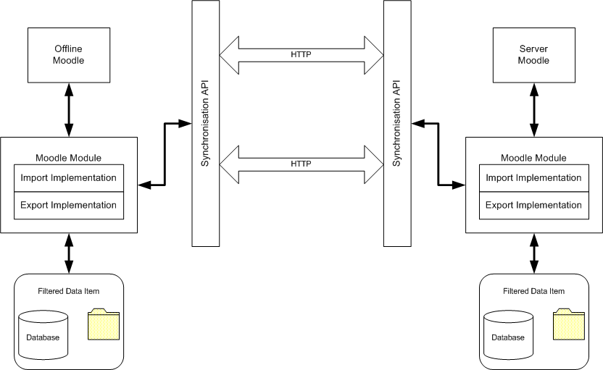

Moodle Offline vs Moodle Hub
Moodle Offline is no different to Moodle on a server.
The perceivable difference is that Moodle Offline operates on a personal desktop computer and does not expect other internet users to connect to it; rather Moodle Offline connects to Internet accessible Moodle instances.

Moodle Offline Operating Stack
Moodle Offline should operate on a standard LAMP/WAMP stack.
Primary development focus is on a Microsoft Windows operating platform.

Moodle Offline Deployment
Moodle Offline will incorporate an installation wizard that guides a user to installing Moodle Offline with no technical expertise or intervention being required.

Moodle Offline Development Framework
Moodle Offline is a reference to Moodle having the capability to operate while disconnected from the internet with the ability to synchronise local data and server data changes when connected to the internet.

This ability is by default disabled on Moodle Hub and Moodle Offline.

It is enabled on a Moodle instance on a module by module basis, and only when a Moodle module has been extended by a developer to support the capabilities of Moodle Offline.
To support this, Moodle Offline offers:
- a development framework that offers a Moodle Offline API to enable data synchronisation processes from Moodle Offline to Moodle Hub for a Moodle module;
- a core infrastructure code addition to the Moodle codebase to support data synchronisation across the Internet through HTTP/HTTPS;

Moodle Data
Moodle Offline is concerned with synchronisation of Moodle data that can take two forms: database records or as binary documents.

Moodle data can also be categorised as follows:
Moodle System Data
- Moodle Administration Data
- Moodle Blocks Data
- My Moodle Data
  - Moodle Blocks Data
  - Moodle Module Data
- Moodle Course Data
  - Moodle Blocks Data
  - Moodle Module Data

Moodle Offline focuses on Moodle data at the Moodle Module level.

However Moodle Offline cannot operate without data from the other Moodle data categories and as such Moodle data pertinent to allowing Moodle to operate and also relevant to the Moodle Offline user will be synchronised automatically if not explicitly requested by the Moodle Offline user. For example, system roles, groups and relevant course data may need to be synchronised to allow a Moodle Forum to function.

Moodle Data Synchronisation Processing
To enable data synchronisation, the following principles apply:
- Moodle data (whether it be table record or binary document) must have a unique identifier;
- The unique identifier must be unique across space and time; i.e. a unique identifier on one Moodle instance should not exist on another Moodle instance if they are not considered the same data;
- Moodle data generated on one instance of Moodle and which are relevant for data synchronisation must have its update (which also implies create) and delete operations recorded/audited; the audit log is the basis of recording changes on one Moodle instance that can be used to recreate the same data on another Moodle instance;
- Each Moodle instance that synchronises with another Moodle instance maintains a SYNCHRONISATION record that records the last data set that was synchronised;
- The Moodle Offline instance must always begin the synchronisation process. This is to reduce load and requirements on the Moodle Hub to avoid the requirement for it to continually listen for synchronisation attempts.

In the basic solution design, data synchronisation as a process is about:
- identifying all the possible data changes (database and binary data) on one Moodle instance;
- transferring them from one Moodle instance to another;
- and recreating the data changes on the receiving Moodle instance;
This base solution is the basic mechanics of data synchronisation.
Higher-level logic such as data selection and filtering for security and optimal data processing are an additional application layer that enhances and enriches the basic mechanics of data synchronisation.

Moodle Data Transfer Mechanism
At the system level, data transfer is focused on the network protocol used to transfer data and what optimisation strategy can be used to utilised available network bandwidth.
Initial thoughts are:
- use HTTP/HTTPS as network protocol; no firewall issues and simple technology;
- use compression of data where appropriate;

At the user level, data transfer is focused on offering the user the ability to control when data synchronisation (and therefore data transfer) actually starts.
Initial thoughts are:
- User can control/schedule synchronisation periods; one to many?
- User can restrict and control the network bandwidth used during synchronisation?

Moodle Data Selection
At the system level, data selection is focused on:
- Identifying the necessary supporting data to allow Moodle to operate;
- Ensuring that data security is maintained such that only data pertinent to the user is selected for transfer;

At the user level, data selection is focused on:
- Allowing the user to control what data to select for transfer via some form of subscription management interface;
- Allowing the user to remove data that has been synchronised without actually deleting the data on the remote Moodle Hub;

Moodle Data Synchronisation Conflict Resolution
During data synchronisation, data conflict will inevitably arise.
This is exacerbated in a multiple Moodle Offline to multiple Moodle Hub environments.
Initial thoughts:
- The system, where appropriate, should resolve conflicts itself;
- Users can specify default conflict resolution strategies that the system can follow;
- Users can confirm automated conflict resolutions suggested by the system;
- Users can specify conflict resolution actions when a decision is required;

Moodle Offline User Interface
Although Moodle Offline is considered a normal Moodle instance, compared to a Moodle Hub it may lack system data, site administration data and course level data to make it a meaningful application.
In theory, a Moodle Module can be synchronised such that it can function exactly on a Moodle Offline as it does on a Moodle Hub. However, how does a user access a Moodle module on a Mobile Server if there is no course or site level information that indicates the Moodle module and its services are available?
This issue indicates that some data not directly relevant to the Moodle module being synchronised needs to be passed to Moodle Offline.

The data set in this case can be categorised as:
- Site level data
- My Moodle level data
- Course level data

Site level data: is referenced to those data and services made available to any Moodle user outside of a course. The only pre-requisite is to be logged in to Moodle;

Course level data: is referenced to those data and services made available in the context of a course. The only pre-requisite is to be logged in to Moodle and to be registered on a Moodle course.

My Moodle level data: is reference to those data and services made available to a user (they may be course level services) but presented as specifically owned and managed by the user. The only pre-requisite is to be logged in to Moodle and to have access to My Moodle.

Notes: My Moodle may be the bridging interface we need that allows us not to synchronise course level data and also avoid having to expose Moodle at the site level.

Other Moodle Issues
Moodle has CRON/Scheduled background processes. These need to be considered for Moodle Offline.

Scheduled System Updates
Should facilities be provided to automatically update Moodle Offline on a scheduled basis using the same synchronisation process defined here.

4.0 Moodle Offline Developer Framework

Overview
The following diagram summarises the solution architecture:

Key points:
The approach we are advocating can be summarised in the following points, which are elaborated upon later:
- Standard API Framework
- Object Oriented
- Optional
- Module Specific Implementations
- Choice of Approaches
- Exact replica
- Start small
- Supporting Components
- Reduce Functionality on Mobile
In addition the following development objectives have been set:
- Minimize network transfer.
- Minimize extra storage needed for synchronisation.
- Minimize code changes.

Standard API Framework
The solution is to offer a standard, preferably simple, API Framework that each and every Moodle Module or Moodle Block (henceforth always referred to as Moodle Modules) must implement in order to allow synchronisation. The framework will coordinate synchronisation of courses and related resource and activity modules from a Moodle Hub to a Moodle Offline instance.

Object Oriented
The API Framework defines an object oriented class interface that defines the API calls available for synchronisation. In addition, the API Framework mandates some changes to the underlying database tables that support the Moodle Module.

We have focused on developing a simple API which can be applied to all modules. The overall process can be broken down into the following sub processes:

- Data Identification: Recording changes and collating data to synchronise
- Data Filter: Satisfy security, privacy and efficiency requirements
- Data Transfer: Get data from a Server to a Mobile instance
- Data Merge: Resolve conflicts that arise
- Data Update: Apply changes to the database

Optional
The API will be optional in that it will not be mandatory for a module to support it. If a module is to use the feature, all that will be required will be to write a controller object which handles the parts of the synchronisation process which are specific to the module.

For example step 3 ‘Data Transfer’ will be transparent to the module. It is likely that the developer will have to pay attention to the remaining steps. However the API will attempt to minimise the amount of work required by each module to achieve its aims. It is expected that only those tasks specific to the module will need to be developed before a module can be considered to support the synchronisation feature. The aim is to provide many helper methods to significantly ease development and support of the module synchronisation in the future.

Module Specific Implementations
Moodle Modules will provide their own specific implementation of the API Framework; with the parts being
  - an implementation for Import on the Server-side
  - an implementation for Export on the Server-side
  - an implementation for Import on the Offline-client-side
  - an implementation for Export on the Offline-client-side

The assumption is that import and export may differ in complexity based on whether it’s on the Server-side or on the Offline-client side; e.g. on the server side, security is more important.

Choice of Approaches
The available choices for updating the database with the imported information are:
- directly update to the database;
- update the database via the create, update and delete methods defined for the module.
- A solution that uses both approach A and B.

For a more detailed discussion visit the section on the Data Update process

Exact Replica
The goal for a Moodle Module implementing the Synchronisation API Framework is to isolate and record the key data item changes that need to be captured on one server to reapply on another server. This principle means that we don’t attempt to capture every possible Moodle data generated, just those data that is pertinent in reassembling the Moodle Module context from one server to the next.

The overall requirement is that after a synchronisation session the databases on the servers must be identical at the record level for the items that were synchronised. This will ease the management of the servers and assist in determining the source of a problem by comparing the records on each server.

Start Small
Rather than enable synchronisation for all modules right away. We have decided to focus on enabling synchronisation in one resource module and one activity module. The assumption is that through this process many methods will be developed which can be reused by other modules to quickly enable synchronisation. The modules we have chosen are:
- activity module: Forum
- resource module: the generic ‘resource page’

Supporting Components
In order to effectively synchronise modules it is also necessary to support synchronisation of supporting components. We have categorised these components into the following:
- Core
- Course
- Mobile

The purpose of these categories is to identify data which has a site wide impact and is fundamental to all courses and modules, the core data, data which applies to specific course instances, the course data and finally data which should not be synchronised such as meta course information, the mobile data. This relationship is demonstrated in the Figure 1 below.
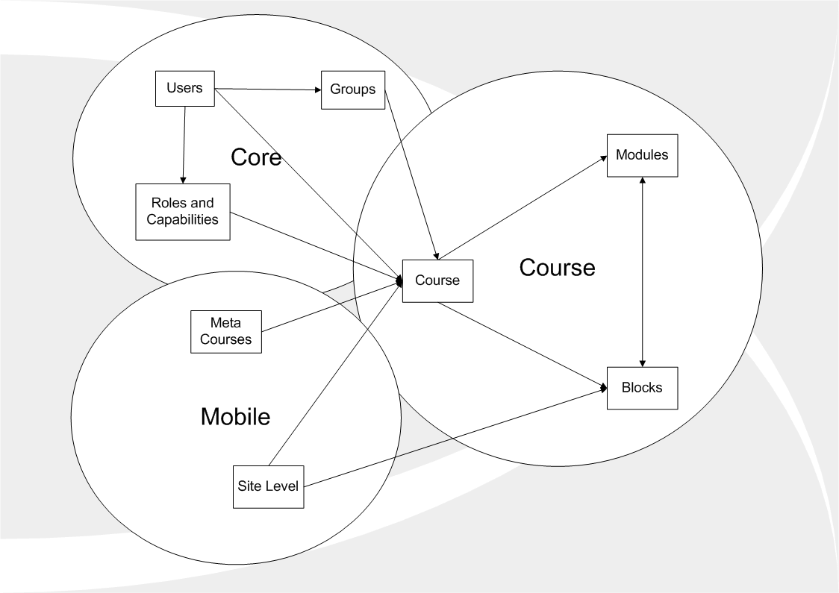
Figure 1: Relationship of Moodle components to the Moodle Offline process

Reduced Functionality on Mobile
Due to the complexity of the synchronisation process it seems best to restrict the functionality available on the Moodle Offline instance. Specifically changes to the core components will only be possible by administering the Moodle Hub directly; there will be no options available on the Moodle Offline instance. Changes to course components will be possible and incorporated as part of the synchronisation process.

Therefore adding users, groups, roles and blocks will only be possible via the Moodle Hub. However it will be possible to add and update
- groupings, groups inside groupings and members to those groups
- block instances in the course pages
- participants
- course roles for users

Ultimately this fits in with the Mobile Moodle concept because the Moodle Offline instance will enable users to efficiently and easily work on their courses.

Current Achievements
The working demonstration we have provided at this point provides a functional foundation from which to build the full synchronisation component. It is recognised however that the component is not complete and more development work is being undertaken to refine and extend the current solution.

The current code provides a working demonstration of:
Step 1: Data Identification
Step 5: Data Update

The code successfully synchronises all core and course components. Core components are synchronised to the Moodle Offline instance by deleting the data and then repopulating tables with information from the Moodle Hub. Courses are simply added, updated or deleted as required. The forums are the only components who’s edit history is tracked by the synchronisation component. This data is thus used to provide an exact copy of the forum structure and content on the Moodle Offline instance and thus prove the basic functionality of the synchronisation process.

Planned Development
This posting marks the end of our initial proof of concept stage. We feel we have now demonstrated sufficient functionality to take this to the next phase where we plan to develop a more complete solution to release to the Moodle community. We are hosting a Moodle Moot in October 2007 at which point we expect to be in a position to present this component in its first working release.

The plan for the next phase is as follows:

Address key issues such as:
- Generating unique ids for all data records: This is part of making the application ready for enterprise level tasks by ensuring that each item of data has an identifier that is unique across all instances of Moodle for the table it resides in.
- Implementing the remaining steps including:
  - Step 2: Data Filter
  - Step 3: Data Transfer
  - Step 4: Data Merge

Extend current sub components. General improvements will be made. The most significant of which will be:
- Over haul the administration interface to provide a cleaner more powerful feature set.
- Enable synchronisation from Moodle Offline to Moodle Hub.

Finally we intend to enable the synchronisation process for the ‘Resource Page’ component.

General

Unique Ids
The entire synchronisation process depends on each item of data having an identifier, primary key, that is unique across all instances of Moodle. This is essential for:
- Identifying which Moodle instance created the item initially.
- Determining whether similar Items stored on separate Moodle instances represent the same item and should be treated the same or different items which should be treated according to different criteria.

To implement this unique id we have multiple options. We can:
- Use a GUID (also named UUID) as the key. This is a 128 bit number that is guaranteed to be unique (based on hardware and on time).
- Use a prefix by server to generate new ids.

We are favouring option 2 because:
  - it has the smallest storage requirement
  - it is possible to determine the Moodle instance that initially created the item
  - it offers an order where as Option 1 does not

Ideally, the unique id is generated immediately when the record is created. The data synchronisation process should be in the position to assume that module, table, ids are unique.
Initial feasibility studies have determined a means for doing this with little change to Moodle core.

Synch Audit Table
Each Moodle Hub must have an SYNCH_AUDIT table to record all modifications that need to be synchronised.
It is populated by Moodle Modules that implement the API Synchronisation Framework.
The SYNCH_AUDIT table records database changes and text/binary file changes.

The Table Structure is as follows:

ID (Globally Unique by table)
SERVER ID (id of the server that entered the record)
MODULE ID (id of the module the data item relates to)

TABLE ID (Used by modules to identify the table)

LAST_UPDATED (Time stamp in Universal GMT record the time of the change)
ACTION Options include CREATED, UPDATED or DELETED
TABLEROW ID (Id of the data item in the table)

Notes:
- Every record is given a date time stamp to record when the action took place;
- SERVER ID stores the id of the server that has done the action. This will be used to avoid loops in the synchronization process.

Record creation, updates and deletion will be explicitly marked in the action field to enable the synchronisation process detect and handle errors.

The SYNCH_AUDIT table is used to support the recording of what has changed on one server and needs to be updated on another Moodle instance.

Note 1: if we consider a tree of synchronised servers, we can flush the SYNCH_AUDIT tables only on the leaf nodes of the tree.

Note 2: we are currently ignoring the reading of data records. However we have now added a task to begin recording read actions as update items.

Synch Status Table
Each Moodle Hub must have a SYNCH_STATUS table to record where the last synchronisation occurred between the servers for each table.

The table structure is as follow:

SERVER (Prefix of the server)
TABLE ID (Used by modules to identify the table)
LAST_LOCAL_ID (last local synchronised id in the table)
LAST_REMOTE_ID (last remote synchronised id in the table)

Note: if we consider a tree of synchronisation servers, we have to maintain the SYNC table only on one side of the connections on the slave server. A slave server can have only one master server but a master server can have multiple slave servers.

Data Identification
This process signifies the start of a synchronisation session. As indicated by Figure 1 the key sets of data to transfer are:
- Core
- Course
- Module

The Mobile data is ignored.

Core Data
A number of components need to be synchronised before successful synchronisation of courses and their modules is possible. These are:
- Users
- Groups
- Roles
- Blocks

Each component contains different amounts and types of data but the overall process used remains the same for the purposes of this discussion.

The synchronisation of these components has been kept simple by the requirement previously outlined that core components cannot be administered by the Moodle Offline instance. The size of this data is currently expected to represent a small subset of data compared to the data involved in the course and module synchronisation. Due to this the synchronisation of core data has two simple steps

- Flush core data
- Import core data from server

When the Data Filter process is developed it will be added as part of step 2. When the other components have been developed and tested it is likely that the knowledge gained will be used to redevelop the ‘Data Identification’ process and use proper synchronisation methods. Until then this process is deemed sufficient.

Course Data
When preparing the Course level data it is key that the core data has already been prepared. It is common for course level and module data to reference core data. For example Role assignments where users are given specific roles within courses or modules are common place. Because the core user data such as their profile has been transferred it is only necessary at the course level to transfer minimal data about the new assignments.

As a short demonstration we have summarised the data that must be collected to support courses and modules within courses.

Course level components
- Courses
  - Blocks
  - Groups
  - Role Assignments

To summarise module level supporting data we have chosen Moodle Forums as an example. The specific data required may change according to module requirements.

Module (Forum) level components
- Module
  - Blocks
  - Role Assignments
  - Course Data

Process
A diagram of the data identification process is available in Appendix B.
The process of identifying data for synchronisation involves 6 steps:
- User expands course or module field
- Local Moodle queried for related item details using synchronisation api
- Moodle Hub queried for related item details via web service api
- View updated to include latest field information

The information returned will include:
- Size in KB
- Item name
- Item Type – Course, Forum, Quiz

Assumptions
- The specific user interface provided may change the underlying capabilities will remain the same. The need is to be able to report on the items available for synchronisation and their potential size/bandwidth use.
- Moodle Network functionality will be used to provide the data transfer and ensure security while providing access to the required synchronisation summary API on Moodle Offline and Moodle Hub
- The synch view should indicate both what items are available and which would need synching.

Data Filter
There are two main reasons to perform filtering:
- Enforce security constraints to ensure Moodle Offline is not passed sensitive information.
- Uphold privacy to comply with the data protection act and other relevant legislation.
- Improve transfer efficiency by reducing the amount of data transferred to the minimal amount necessary.

Security and permissions will become an important issue, particularly on the Moodle Hub. Before any data is sent from the Moodle Hub it must be filtered according to the security constraints applicable to the user associated with the Moodle Offline instance. This will mainly involve removing items from the data set which the user does not have permission to access. It will also support two levels of filtering:

- Core Data: Access to fundamental data such as Users and Permissions must be tightly controlled
- Course Data: Access to Course Data must be determined with careful consideration of security and other considerations of firstly Core Data and then Course Data.

Data Transfer
The pertinent decision in the data transfer process is the transfer protocol to use.

Notes:
Use SOAP or XMLRPC over HTTP/HTTPS.
Data is always pulled from the server by the client; so the only requirement is the outgoing firewall port on the UMPC being enabled.
We may use compression technology in the HTTP data stream.

Our preference is to use SOAP.

Data Merge
The data merge process is concerned with merging two separates instances of Moodle data into one. Work has not begun on this process so the theory is still in development.

The merging process is described in greater detail in the later section on the Administration Interface. The topic of most relevance is item 2 Export as this is where merging will occur.

Data Update
The primary concern in the process is updating the local Moodle instance with the items from the remote instance. The process itself is heavily tied to the process of merging the data and so considerable overlap may exist.

As the data transfer process has not been defined or developed at this stage, for the purposes of this discussion we will assume that it is in place. Therefore the ‘Data Update’ process will simply extract the necessary data from a locally stored data source. We will assume that the data source provides sufficient data in the appropriate format for entry into the database.

When describing the update process we assume the synchronisation being performed is from the Moodle Hub to the Moodle Offline instance. Therefore the term ‘export’ refers to data sent from the Moodle Hub and ‘import’ is data received by the Moodle Offline instance. When the synchronisation process is from the Mobile instance to the Server, ‘export’ refers to data from the Mobile instance and the ‘import’ is to the Server.

In developing the update process we identified following possible solutions:
- Record and log all database and file changes for export and on import replay all the changes – this is a pure data transfer route;
- Record and log all database and file changes for export and on import reapply all the changes by making the necessary Moodle Module function calls – this approach assumes we packaged all the necessary data to call Moodle Module function calls to reapply all the data.
- A solution that uses both approach A and B.

The intention is to allow each module to determine which of the above solutions to take when developing the synchronisation process. This is to give the developer greater flexibility particularly if there are constraints specific to the module or component which must be taken into account.
As an example, a Moodle Module may choose to offer synchronisation by simply recording all database changes (updates, deletes, and inserts) and simply reapply all these changes on import. Moodle Modules such as read-only bulletin boards are a good example for this approach.

An example of the update process where we intend to use function calls to recreate the data as opposed to directly touching the database is in the example of Moodle Forums. Moodle Forums has add, update and delete instance functions for the majority of its data items. So on import, the solution is planned to provide enough information to trigger the appropriate function to recreate the Forum structure and content while ensuring that security and other key processes are undertaken to protect the integrity and security of the underlying data and the database.

Investigation of solution b has identified that in general this approach is entirely appropriate and achievable with the current implementation of Moodle Forums. However there are some key concerns to be addressed. The most pertinent are:
- The add, update or delete functions are not used uniformly. Specifically, for example, the function ‘forum_add_discussion’ creates a post directly calling ‘insert_record’ instead of calling the function ‘forum_add_post’.
- Id values added must match those on the Server. The update process must copy data exactly. The add functions along with the dmllib.php code must be modified to allow ids to be inserted when necessary rather than generated at the time of insertion.

We are confident that both of these concerns can be addressed in the current Moodle Forum code however it would represent a fundamental change to the workings of the forum. We aim to make these changes in order to ensure the proper security and data constraints are imposed during the update process. However we welcome and encourage feedback on the best way we can achieve this.

User Interface

Overview:
The synchronisation of Moodle Components is a complex process which is guaranteed to require input from the user. A basic configuration interface will be provided using the standard functionality provided by Moodle blocks. This will allow configuration of Moodle Hub and Moodle Offline details and specific defaults to be used during the synchronisation process. The administration of the synchronisation process itself will provide methods to resolve merging conflicts that occur when the same item has been edited by multiple Mobile instances.

Snapshot
A snapshot has been provided to demonstrate the latest approach for the user interface see Appendix A. The snapshot includes demonstration of basic pages and a wireframe diagram of the pages expected in the feature.

Process
There are two distinct sub-processes to the overall synchronisation process following the principal that the mobile instance must initiate and control the synchronisation process. These are:

- Identification. The mobile user must select the mobile and server data to synchronise
- Export. Synchronisation of data from the server to the mobile instance.
- Import: Synchronisation of data from the mobile instance to the server.

The export process must happen before the import process. Therefore the export process will present the greatest challenge because all merging conflicts must be addressed. This makes the import process very simple since all conflicts have been dealt with and data can be updated without further processing.

The option exists to perform the export and import processes as discrete steps. Synchronising each set of data in turn. This would result in a lengthy and inefficient process. Therefore once the data set, the items to be synchronised, has been identified by the user the export process will be applied to entire the data set before the import process can be applied.
Now we will illustrate this process in more detail.

Step 1: Identification of data
The synchronisation process has the potential for taking longer than the user would prefer if for example the Mobile Moodle instance contains a large number of courses and modules that could be synchronised, and the internet connection speed and bandwidth being used is limited. To address this we feel it best to allow the user to synchronise only the items they desire. For example there may be courses and modules available on the Mobile instance that the user is following but is not working on at the current time. Thus related changes are not relevant as they can be synchronised at a later time. Therefore an interface will be provided to enable the user to identify the data that is relevant to this synchronisation session. This has the added benefit of also reducing the load on the server. The level of granularity provided is yet to be determined. The user will not control synchronisation of core data as this will be handled internally. The user will only control the synchronisation of course data. We plan, initially, to provide the option to select items at the level of courses and forums but not discussions or posts.

Step 2:
The main challenge of the export process is handling conflicts where items have been edited by multiple Moodle Offline instances or by the Moodle Hub itself.

The overall process is expected to be:
- From the synch tables identify the items with and without conflicts.
- Synchronise the items without conflicts ignoring the items identified as having a parent with a conflict.
- Return to the Mobile instance details of the items with conflicts along with details necessary to resolve the conflict.
- The user at the mobile end will choose to either:
  - update the server with the change on the mobile instance.
  - leave the server unchanged. This will remove the record of the change from the Mobile instance ensuring that the conflict is resolved. The local item will only be updated when the import process is run.
  - edit their post on the Mobile instance, make the necessary changes and then post this update to the server taking account of the conflict.
- Repeat steps 2, 3 and 4 until all conflicts have been resolved.

Assumptions
- Only Items the user has rights to can have conflicts as a user cannot update or delete items owned by others.
- Only items with matching database id values may cause a conflict. Therefore items may have similarities such as names or contents without creating a conflict because their database id will be different.
- An ignore option will be provided. There are many possible reasons for this including:
  - The item(s) may be too large.
  - The user may not want/be able to make the decision at this point.
- A merge feature will not be required in this project. The reasons are thus:
  - The user will have the facility to copy the content of both the remote and local data items and merge the content as they see fit using the standard interface.
  - Providing the ignore option will allow the user to record the contents of each item for manual merging later into the local Moodle instance. Then the merged data can be uploaded to the remote instance during the standard synchronisation process by choosing the local version over the remote.
- The user administration interface will be available on Moodle Offline and severely limited on Moodle Hub

Possibilities
- It has been suggested that there could be multiple entry points into the synchronisation feature. For example clicking synchronise from the Moodle Offline home page will display all possible
It is difficult to determine the exact percentage of conflicts that will occur, but it is expected that in practise that only a few items in every synchronisation session would be affected. Our best guess is that, in general, just 1-5% of all items will raise a conflict. Therefore we assume that 95-99% of all items that are exported from the mobile instance to the server will not encounter any conflicts.

The profile of conflicts is thus
 |  | Server
 |  | Created | Updated | Deleted
 | Created | No issue | No issue | No issue
Mobile | Updated | No issue | Conflict | Conflict
 | Deleted | No issue | Conflict | No issue

Instances without conflict include:
- New items: even if the content of forums, discussions or posts are identical, as long as their ids are different, the forum moderator can resolve this problem by transferring necessary data and deleting the relevant item using the standard interface. Subsequent synchronisations on each Mobile instance will ensure that the changes will be passed on correctly.
- Updated items: when the data item has not been updated since the last time the Mobile instance synchronised.
- Deleted items: An item will be deleted when:
  - The user has confirmed the item should be deleted at the point when they deleted it from their Mobile instance.
  - the item has not been updated since the last synchronisation of the Mobile instance

Conflicts will occur in the following instances:
- Updated items: the same item has been update by another Moodle Offline instance since the last synch occurred.
- Deleted items: the same item has been update by another Moodle Offline instance since the last synch occurred.

5.0 UMPC Operating Platform and Software Stack

Notes:
Early indication is that the platform will be:
- Microsoft Windows (XP or Vista)
- Apache Web Server
- MySQL Database
- PHP 5

Although a “lighter” web server may be used, apache web server does not seem to resource intensive.

SQLLite is a potential database option; advantage being it is non-memory resident and requires the least resource. Disadvantage is that it is not database feature rich.

Postgres is another potential database option; advantage being it offers rich database features such as triggers. Disadvantage is its hardware resource requirements.

6.0 Moodle Offline Installation Wizard

Notes:
The model will be akin to a UMPC user installing Microsoft Office.
The user runs an installation wizard that offers some customisation options with the installer then performing the bulk operation of installing Moodle Offline with no user intervention or technical knowledge.

7.0 Moodle Offline Support Issues

Notes
This project is still in its early stages and thus the wider issue of support issues has not be addressed at this point. The key areas of interest are likely to be related to the challenges of providing a support network for users to help with installing and troubleshooting the Moodle Offline application.

There are a number of key issues around this solution overall. The most important being the degree of support for synchronisation provided by the learning centre, be it university or college etc, and that of the wider Moodle community as a whole.

Appendix A: User Interface

Snapshot
A user interface snapshot has been created to assist development of the user interface. The advantages of a snapshot are:
- Exploration of available options
- Facilitates fast and relevant testing by several target markets
- Demonstration environment matches live environment improving accuracy and relevance of experience and feedback.

The latest snapshot is v0.1 and contains:
- Walk-through of moodle home page and conflict resolution page
- Wireframe diagram of synchronisation feature

Appendix B: Data Identification
Process Diagram
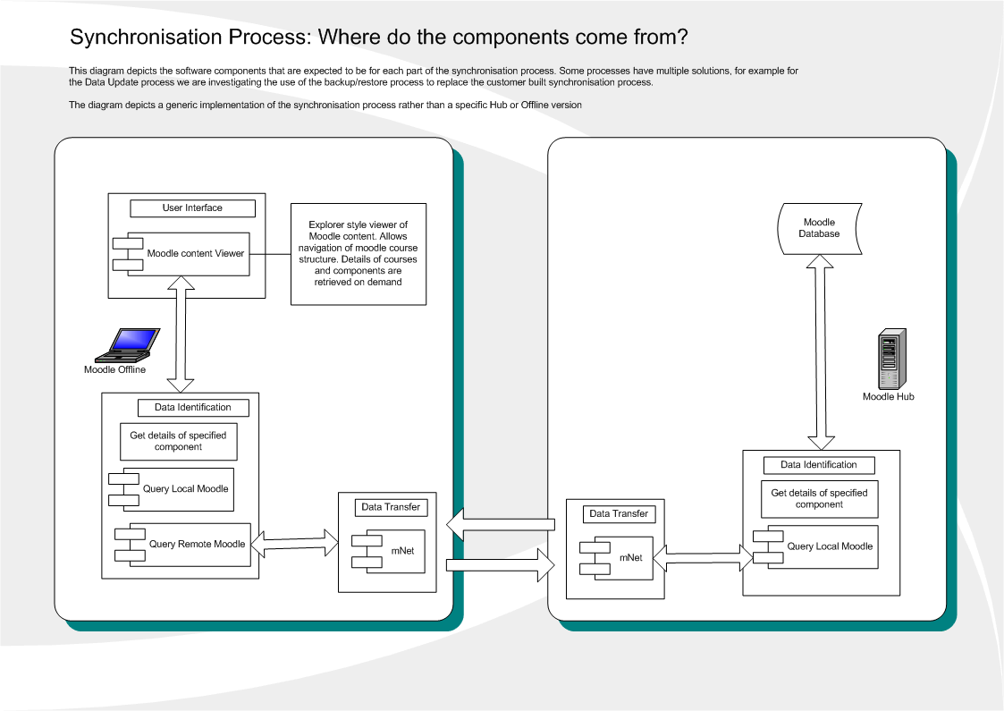
Figure 2. Data Identification Process Diagram

Glossary
Moodle Hub:
The name given to an instance of Moodle operating on a hosted server environment. 2
Moodle Offline :
The name given to an instance of Moodle operating on a desktop personal computer 2
Personal Learning Environment :
is the name given to a learning environment under the control of an individual user. 2
Virtual Learning Environment :
is the name given to a learning environment controlled by a community or often a teaching institution. 2

